**Section10**

**PL/SQL 10:**

CREATE OR REPLACE PACKAGE manage_jobs_pkg

IS

g_todays_date DATE := SYSDATE;

CURSOR jobs_curs IS

SELECT employee_id, job_id FROM employees

ORDER BY employee_id;

PROCEDURE update_job

(p_emp_id IN employees.employee_id%TYPE);

PROCEDURE fetch_emps

(p_job_id IN employees.job_id%TYPE,

p_emp_id OUT employees.employee_id%TYPE);

END manage_jobs_pkg;

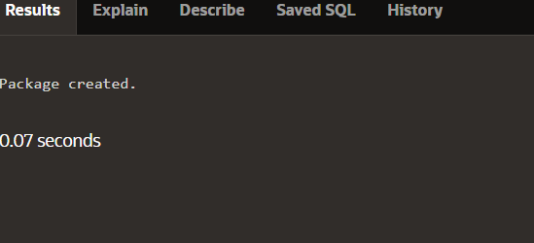

CREATE [OR REPLACE] PACKAGE BODY package_name IS|AS

private type and variable declarations

subprogram bodies

[BEGIN initialization statements]

END [package_name];



CREATE OR REPLACE PACKAGE BODY check_emp_pkg IS

PROCEDURE chk_hiredate

(p_date IN employees.hire_date%TYPE)

IS BEGIN

IF MONTHS_BETWEEN(SYSDATE, p_date) >

g_max_length_of_service * 12 THEN

RAISE_APPLICATION_ERROR(-20200, 'Invalid Hiredate');

END IF;

END chk_hiredate;

PROCEDURE chk_dept_mgr

(p_empid IN employees.employee_id%TYPE,

p_mgr IN employees.manager_id%TYPE)

IS BEGIN ...

END chk_dept_mgr;

END check_emp_pkg;

DESCRIBE check_emp_pkg

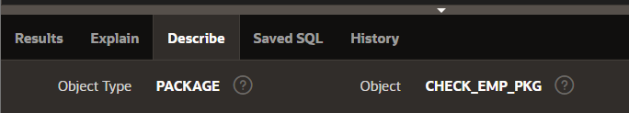

CREATE OR REPLACE PACKAGE salary_pkg

IS

g_max_sal_raise CONSTANT NUMBER := 0.20;

PROCEDURE update_sal

(p_employee_id employees.employee_id%TYPE,

p_new_salary employees.salary%TYPE);

END salary_pkg;

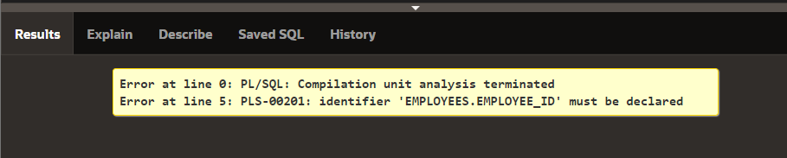

PROCEDURE update_sal -- public procedure

(p_employee_id employees.employee_id%TYPE,

p_new_salary employees.salary%TYPE)

IS v_old_salary employees.salary%TYPE; -- local variable

BEGIN

SELECT salary INTO v_old_salary FROM employees

WHERE employee_id = p_employee_id;

IF validate_raise(v_old_salary, p_new_salary) THEN

UPDATE employees

SET salary = p_new_salary

WHERE employee_id = p_employee_id;

ELSE

RAISE_APPLICATION_ERROR(-20210, 'Raise too high');

END IF;

END update_sal;

END salary_pkg;

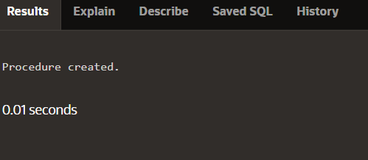

DECLARE

v_bool BOOLEAN;

v_number NUMBER;

BEGIN

salary_pkg.update_sal(100,25000); -- 1

update_sal(100,25000); -- 2

v_bool := salary_pkg.validate_raise(24000,25000); -- 3

v_number := salary_pkg.g_max_sal_raise; -- 4

v_number := salary_pkg.v_old_salary; -- 5

END;

SELECT text

FROM user_source

WHERE name = 'SALARY_PKG' AND type = 'PACKAGE'

ORDER BY line;

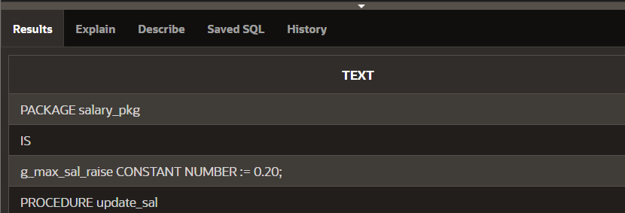

CREATE PACKAGE sample_pack IS

PROCEDURE sample_proc (p_char_param IN CHAR);

PROCEDURE sample_proc (p_varchar_param IN VARCHAR2);

END sample_pack;

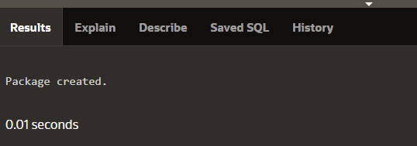

CREATE OR REPLACE PACKAGE dept_pkg IS

PROCEDURE add_department(p_deptno NUMBER,

p_name VARCHAR2 := 'unknown', p_loc NUMBER := 1700);

PROCEDURE add_department(

p_name VARCHAR2 := 'unknown', p_loc NUMBER := 1700);

END dept_pkg;

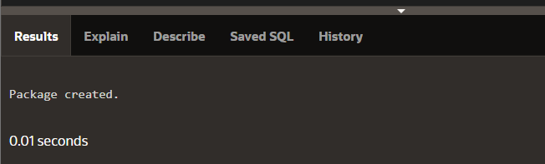

CREATE OR REPLACE PACKAGE BODY dept_pkg IS

PROCEDURE add_department (p_deptno NUMBER,

p_name VARCHAR2:='unknown', p_loc NUMBER:=1700) IS

BEGIN

INSERT INTO departments(department_id,

department_name, location_id)

VALUES (p_deptno, p_name, p_loc);

END add_department;

PROCEDURE add_department (

p_name VARCHAR2:='unknown', p_loc NUMBER:=1700) IS

BEGIN

INSERT INTO departments (department_id,

department_name, location_id)

VALUES (departments_seq.NEXTVAL, p_name, p_loc);

END add_department;

END dept_pkg;



